



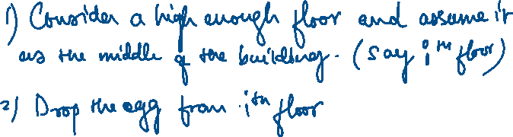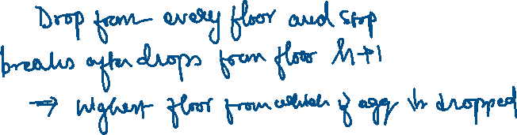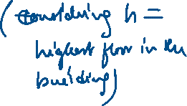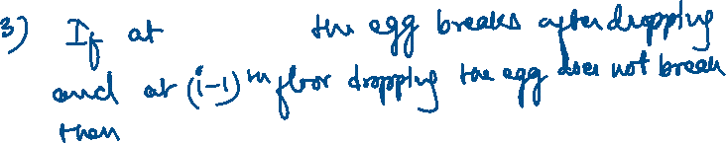

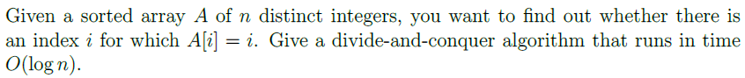



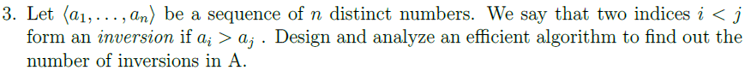

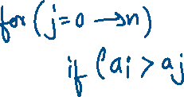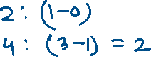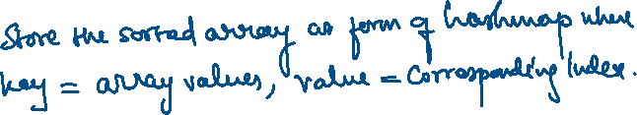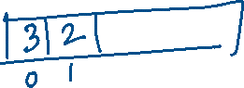

<https://www.geeksforgeeks.org/inversion-count-in-array-using-merge-sort/>

* Using merge sort.